Institute of computer technology

B.Tech-CSE(BDA)

Name:- Shaikh Anik

Sem:-3

Enrollment no.:-23162121021

Batch:-31

Sub:-DBMS

Date:-21/8/24

Practical 6

Q:- Solve the following queries using sub queries:-

1) Find the product_no and description of non moving products i.e. product not being sold.

2) Find the customer name, address1, address2, city and pincode for the client who has placed order no

‘O1901’.

3) Find out if the product ‘Mouse’ has been ordered by any client and print the client_no, name to whom

it was sold.

A=> Query:- use BDA_23162121021;

1) select p.product_no, p.description from product_master p

where p.product_no not in ( select product_no from sales_order_details);

2) select c.name, c.city, c.pincode

from client_master c

where c.client_no = (

select client_no

from sales_order

where order_no = 'o1901');

3) select c.client_no, c.name

from client_master c

where c.client_no in (

select client_no

from sales_order_details

where product_no = (

select product_no

from product_master

where description = 'mouse'

)

);

Screenshot:-

1 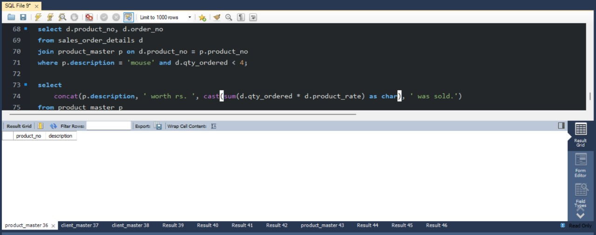

2 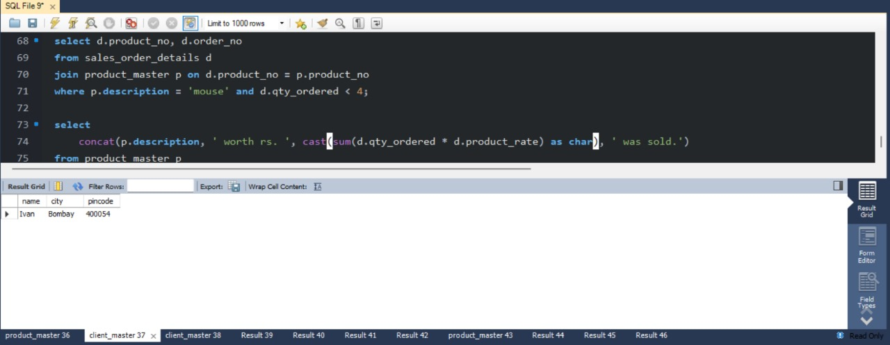

3 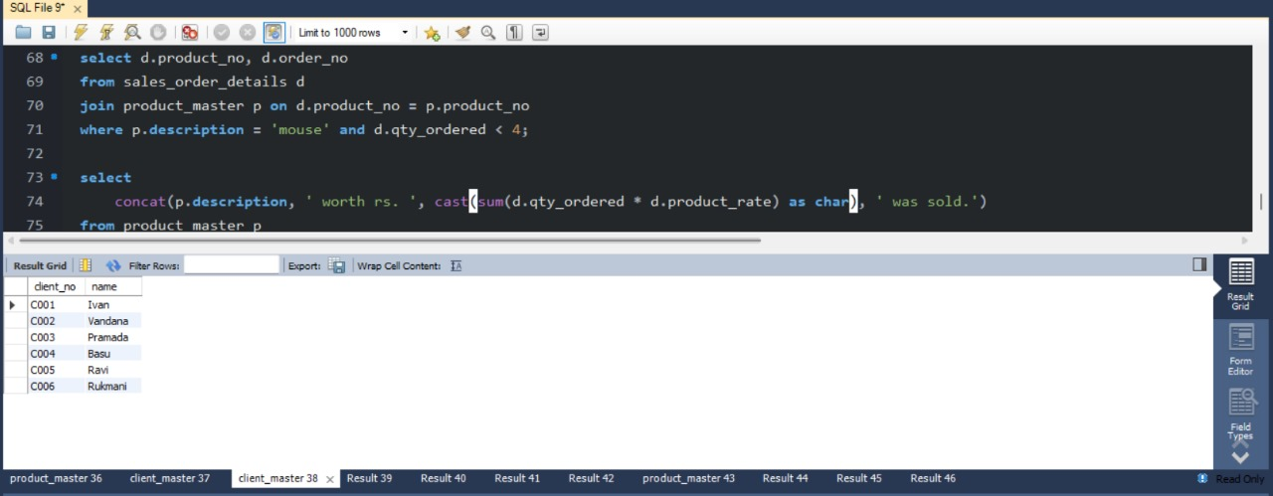

Q:- Queries using Having and Group By Clause:

1) Print the description and total qty sold for each product.

2) Find the value of each product sold.

3) Find out the sum total of all the billed orders for the month of January

A=> Query:-

1) select p.description, sum(s.qty_ordered) as total_qty_sold

from product_master p

join sales_order_details s on p.product_no = s.product_no

group by p.description;

2) select p.description, sum(s.qty_ordered * s.product_rate) as total_value_sold

from product_master p

join sales_order_details s on p.product_no = s.product_no

group by p.description;

3) select sum(s.Billed_yn) as total_billed_orders

from sales_order s

where s.order_date between '01-jan-2023' and '31-jan-2023';

Screenshot:-

1

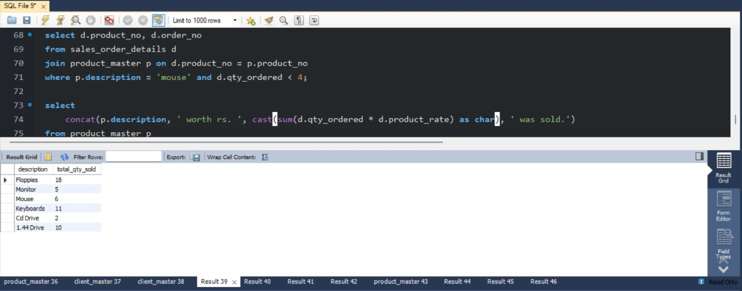

2

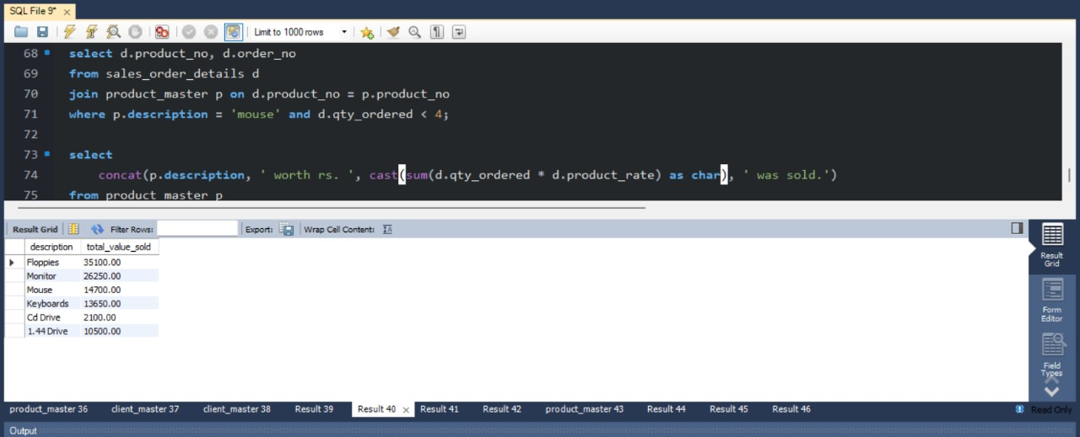

3

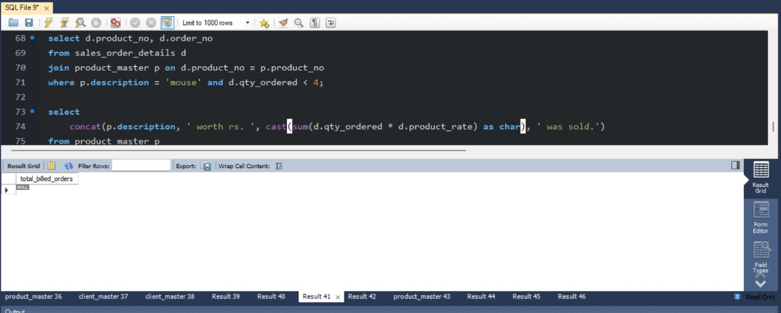

Q:- Queries on Joins and Correlation:

1) Find out the products, which have been sold to ‘Ivan’.

2) Find the product_no and description of constantly sold i.e. rapidly moving products.

3) Find the names of clients who have purchased ‘Cd Drive’.

4) List the product number and order number from customers who have ordered less than 4 units of 'Mouse'.

A=> Query:-

1) select p.product_no, p.description

from product_master p

join sales_order_details s on p.product_no = s.product_no

join sales_order o on s.order_no = o.order_no

join client_master c on o.client_no = c.client_no

where c.name = 'ivan';

2) select p.product_no, p.description

from product_master p

where p.product_no in (

select product_no

from sales_order_details

group by product_no

having count(*) >= 3);

3) select c.name

from client_master c

join sales_order o on c.client_no = o.client_no

join sales_order_details d on o.order_no = d.order_no

join product_master p on d.product_no = p.product_no

where p.description = 'cd drive'

group by c.name;

4) select d.product_no, d.order_no

from sales_order_details d

join product_master p on d.product_no = p.product_no

where p.description = 'mouse' and d.qty_ordered < 4;

Screenshot:-

1

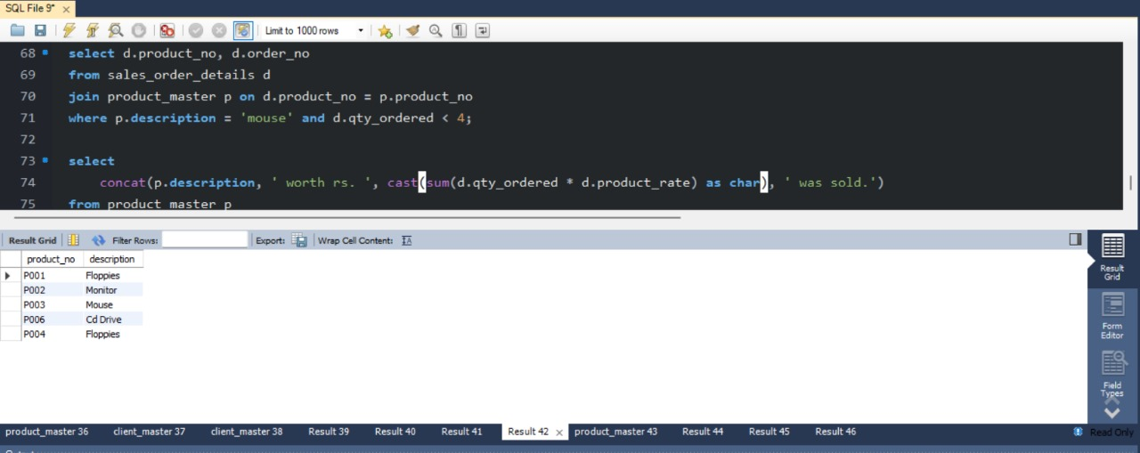

2

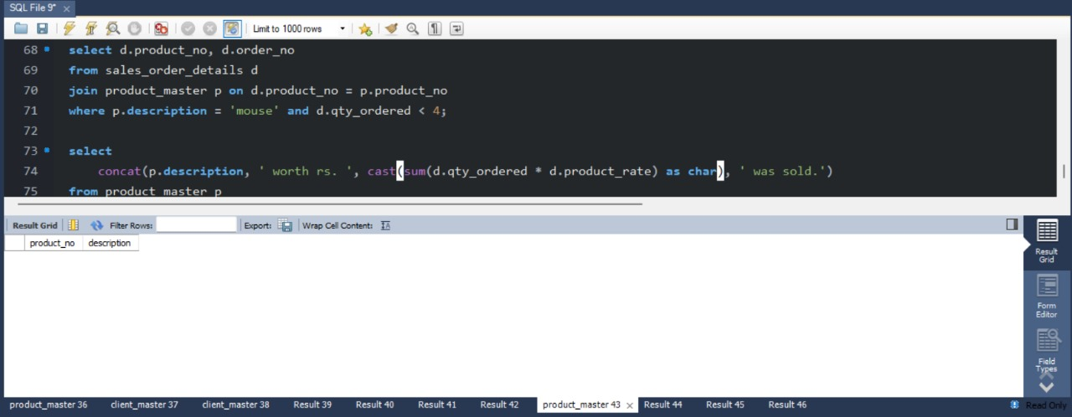

3

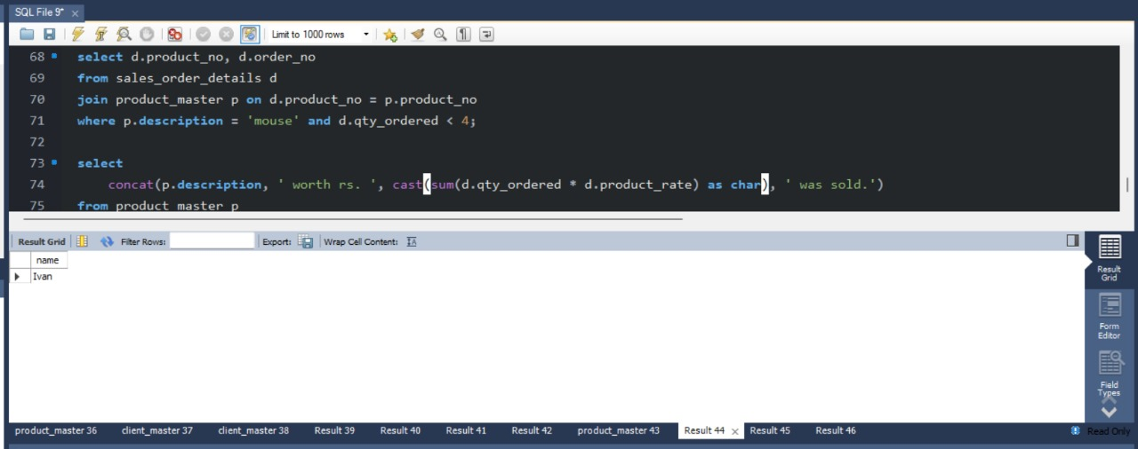

4

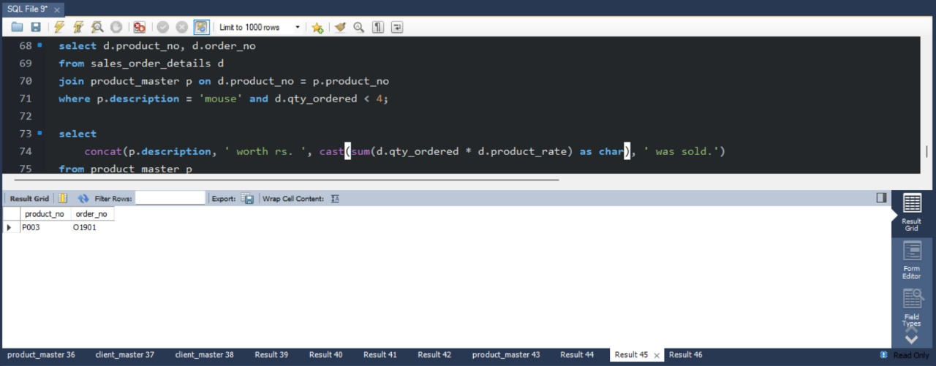

Q:- Queries on Constructing Sentences with data:

1) Print information from product-master, sales_order_detail tables in the following format for all

records:-

{description} Worth Rs. {total sales for the product} was sold.

A=> Query:-

select

concat(p.description, ' worth rs. ', cast(sum(d.qty_ordered * d.product_rate) as char), ' was sold.')

from product_master p

join sales_order_details d on p.product_no = d.product_no

group by p.description;

Screenshot:-

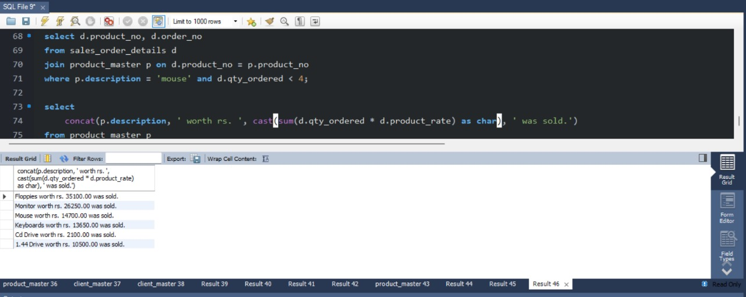

Action logs:- 